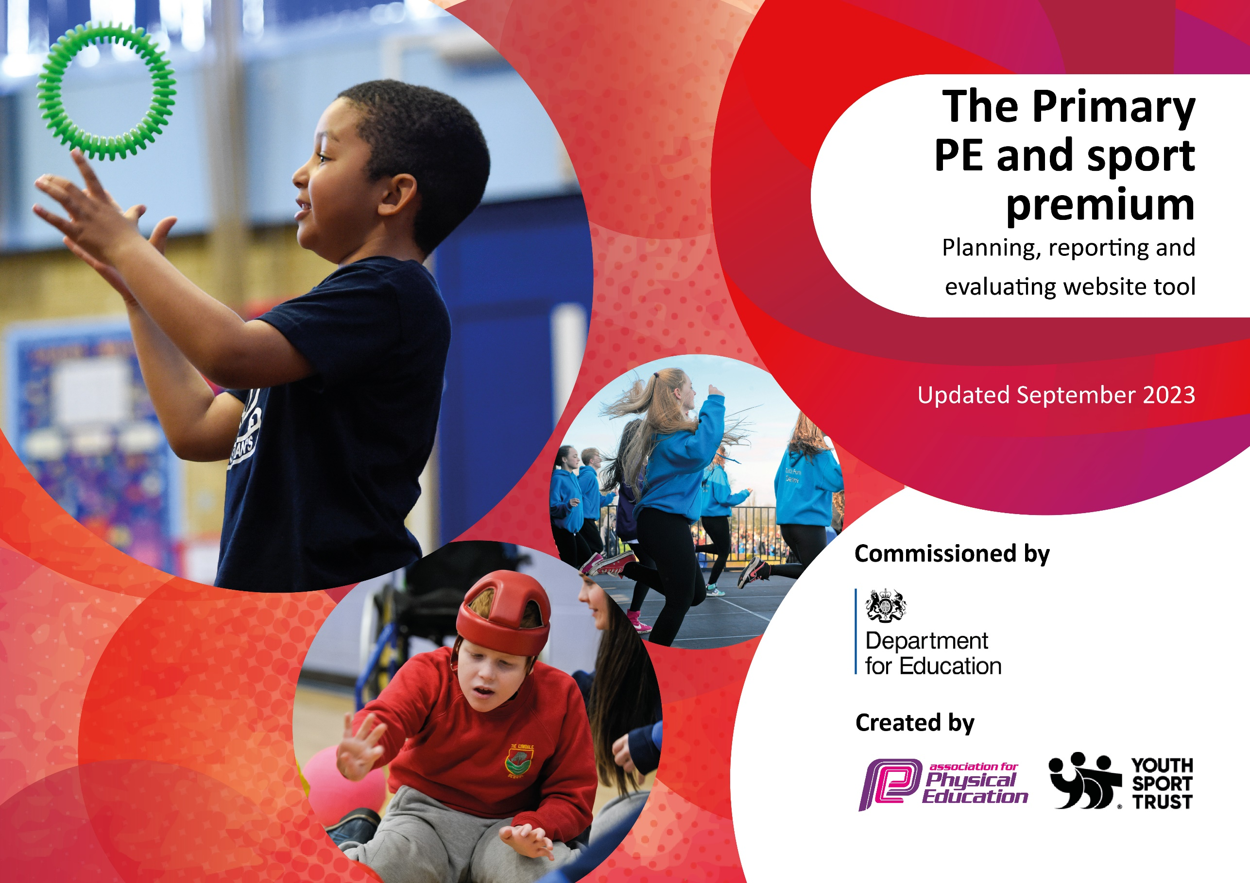

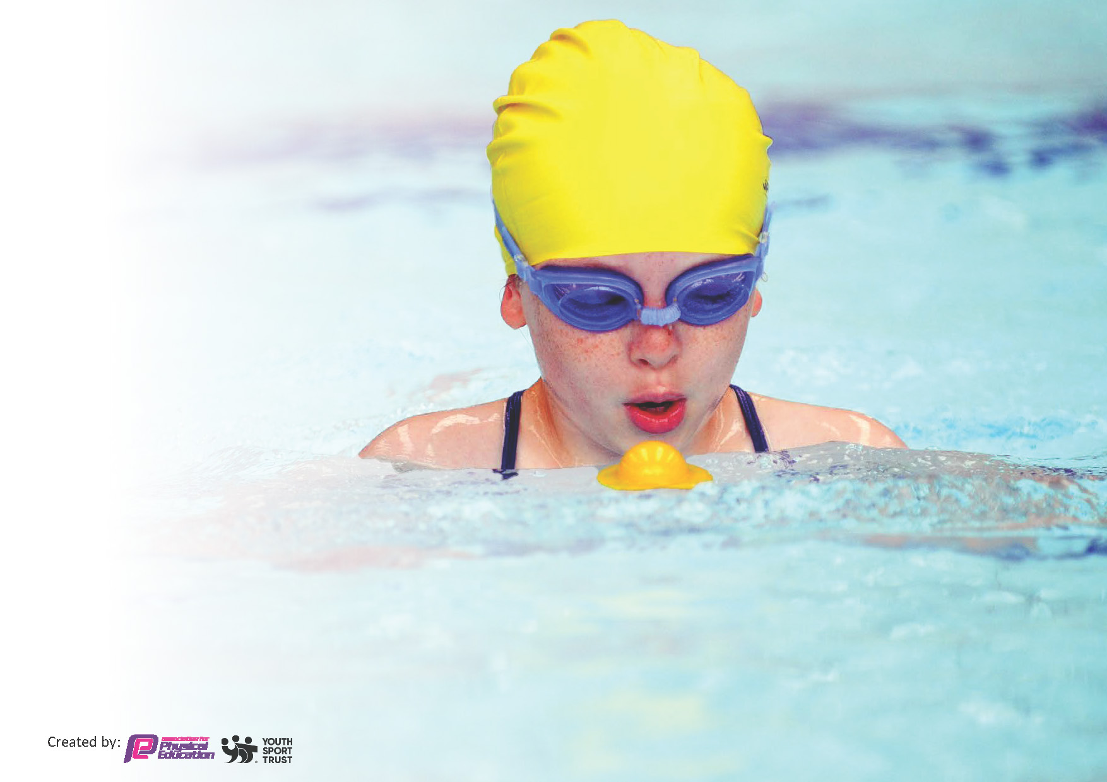
This template can be used for multiple purposes:
by:
- It enables schools to effectively plan their use of the Primary PE and sport premium
- It helps schools to meet the requirements (as set out in guidance) to publish information on their Primary PE and sport premium
- It will be an effective document to support Ofsted inspections enabling schools to evidence progress in Physical Education (PE) and evidence swimming attainment, which forms part of the PE National Curriculum. We would recommend schools consider
the Intent, Implementation and Impact of any spend, as examined within the Education Inspection Framework.

It is important that your grant is used effectively and based on school need.

Schools must use the funding to make additional and sustainable
improvements to the quality of the PE, School Sport and Physical Activity (PESSPA)
they offer. This means that you should use the Primary PE and sport premium to:

- Build capacity and capability within the school to ensure that improvements made now will benefit pupils joining the school in future years
- Develop or add to the PESSPA activities that your school already offers.

The Primary PE and sport premium should not be used to fund capital spend projects; the school’s core budget should fund these. Further detail on capital expenditure can be found in the updated Primary PE and sport premium guidance.

The Primary PE and sport premium guidance, outlines 5 key priorities that funding should be used towards. It is not

necessary that spending has to meet all the key priorities, you should select the priorities that you aim to use any funding towards.

Although completing this template is not a requirement for schools, schools are required to publish details of how they spend this funding. Schools must also outline what the impact this funding has had on pupils’ PE and sport participation and attainment and how any spending will be sustainable in the future. All funding must be spent by 31st July 2024.

The Department for Education has worked closely with the Association for Physical Education (afPE) and the Youth Sport Trust (YST) to develop this template and encourages schools to use it. This template is an effective way of meeting the reporting requirements of the Primary PE and sport premium.
Review of last year’s spend and key achievements (2022/2023)

We recommend you start by reflecting on the impact of current provision and reviewing your previous spend.

Activity/Action | Impact | Comments
- Increased use of all-weather pitches for sports fixtures.  - Continued work with Sports Partnerships and PE Association.  - Hosting/ leading the delivery of new sports in local hubs with other primary schools.  - Increased number of outdoor play opportunities.  - Targeted support through a range of sports coaches. | - Greater number of children participating and increased number of fixtures completed.  - Greater say in activities being provided. School taking the lead on championing new sports.  - Children are actively playing more often at free times in the day with a range of equipment.  - Children have higher-level access to a range of sports outside their curriculum lessons and for interventions. | - To continue into next academic year.

Key priorities and Planning
This planning template will allow schools to accurately plan their spending. Total Funding: £18362

Action – what are you planning to do | Who does this action impact? | Key indicator to meet | Impacts and how sustainability will be achieved? | Cost linked to the action
Increase higher-level delivery of after-school sports clubs | Pupils – as they will take part.  Teaching staff as they will be able to gain CPD alongside the trained coaches. | Key indicator 2 -The engagement of all pupils in regular physical activity – the Chief Medical Officer guidelines recommend that all children and young people aged 5 to 18 engage in at least 60 minutes of physical activity per day, of which 30 minutes should be in school.  Key indicator 4: Broader experience of a range of sports and activities offered to all pupils. | More pupils meeting their daily physical activity goal, more pupils encouraged to take part in PE and Sport Activities- especially after school. | £4000

Membership within a school sports partnership and County PE association.  Broader range of PE equipment purchased to allow children to participate in wider range of sports.  Transportation to national sporting opportunities.  Hire of specialist sporting venues.  Subscription to curriculum resources.  Trophies and medals.  Outdoor Equipment upgrades and refurbishments | Pupils – as they will take part.  Teaching staff as they will be able to gain CPD alongside the trained coaches.  Pupils – as they will take part.  Pupils – as they will take part.  Pupils – as they will take part.  Pupils – as they will take part.  Teaching staff as they will be able to gain CPD alongside the trained coaches.  Pupils – as they will take part, inspired to gain silverware.  Pupils – as they will be using it. | Key Indicator 1: Increased confidence, knowledge, and skills of all staff in teaching PE and sport.  Key indicator 4: Broader experience of a range of sports and activities offered to all pupils.  Key indicator 5: Increased participation in competitive sport.  Key indicator 4: Broader experience of a range of sports and activities offered to all pupils.  Key indicator 5: Increased participation in competitive sport.  Key indicator 4: Broader experience of a range of sports and activities offered to all pupils.  Key indicator 5: Increased participation in competitive sport.  Key indicator 4: Broader experience of a range of sports and activities offered to all pupils.  Key indicator 5: Increased participation in competitive sport.  Key Indicator 1: Increased confidence, knowledge, and skills of all staff in teaching PE and sport.  Key indicator 5: Increased participation in competitive sport.  Key indicator 2 -The engagement of all pupils in regular physical activity – the Chief Medical Officer guidelines recommend that all children and young people aged 5 to 18 engage in at least 60 minutes of physical activity per day, of which 30 minutes should be in school. | Primary teachers more confident to deliver effective PE supporting pupils to undertake extra activities inside and outside of school.  Sustainability achieved through taking a lead on opportunities delivered and using this approach to model further competition opportunities.  Equipment audited and maintained. Quality equipment purchased to help keep it for longer.  A very rare opportunity to participate in national-level competitions.  Children able to participate in sports still even when weather had called off grass.  All staff confident in their teaching of PE. Children able to be assessed consistently and given next steps in their whole primary school journey.  Children are inspired and motivated to take part in a range of sports with promise of a physical reward in different events.  Children have a range of outdoor and adventurous equipment to help with their 30 active minutes. | £4000  £1500  £1500  £1000  £700  £900  £4750

Key achievements 2023-2024
This template will be completed at the end of the academic year and will showcase the key achievements schools have made with their Primary PE and sport premium spending.

Activity/Action | Impact | Comments
- Girls’ Football team reached the final of two national competitions held at Derby County and Brentford Stadium.  - Became lead school in new MAT PE partnership.  - Achieved 98% of children achieving swimming 25 metres by end of Year 6.  - 176 children (60%) of the school took part in at least one inter-school sports competition.  - Developed new sports clubs links with out of school clubs- padel, football, rugby.  - Won 25 local competitions. Took part in 156 inter-school sports fixtures across 36 different sports this academic year. | - More children than previous year achieving 30 active minutes.  - More children inspired to take up an after-school sports club and compete in after-school fixtures.  - School received prestige on a national level.  - Number of girls participating has increased.  - Number of identified low-participators now taking part in at least three events has now increased.

Swimming Data
Meeting National Curriculum requirements for swimming and water safety.
Priority should always be given to ensuring that pupils can perform safe self-rescue even if they do not fully meet the first two requirements of the National Curriculum programme of study

Question | Stats: | Further context  Relative to local challenges
What percentage of your current Year 6 cohort can swim competently, confidently and proficiently over a distance of at least 25 metres? | 98% | The one child who could not achieve this went from someone unable to enter the water to achieving their 5 metres
What percentage of your current Year 6 cohort can use a range of strokes effectively [for example, front crawl, backstroke, and breaststroke]? | 93% | Two of the three children who did not achieve this could still swim 25m using front and back stroke.

What percentage of your current Year 6 cohort are able to perform safe self-rescue in different water-based situations? | 66% | Children have had time to develop this skill as they have been swimming in both Year 5 and Year 6.
If your schools swimming data is below national expectation, you can choose to use the Primary PE and sport premium to provide additional top-up sessions for those pupils that did not meet National Curriculum  requirements after the completion of core lessons. Have you done this? | No | This hasn’t been required.
Have you provided CPD to improve the knowledge and confidence of staff to be able to teach swimming and water safety? | No | We employ extra specialist coaches at the swimming pool to deliver our lessons for those with most need.

Signed off by:

Head Teacher: | Daniel Webster
Subject Leader or the individual responsible for the Primary PE and sport premium: | Ryan Walker
Governor: | Amy Barrett
Date: | 19.7.24

