Sharing book – reading for pleasure

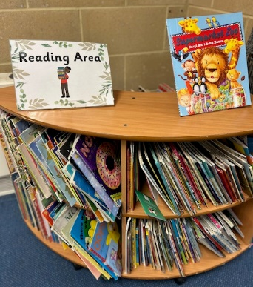
Your child will also bring home a sharing book from our book shelf to enjoy. This is for you to read to them. Talk about the book – the characters and their feelings, the plot, the setting etc. Sharing books will provide a rich vocabulary and a range of text types. The children can enjoy hearing quality texts without having to think about decoding! We don’t expect you to read this 5 times – just enjoy it as many times as you like
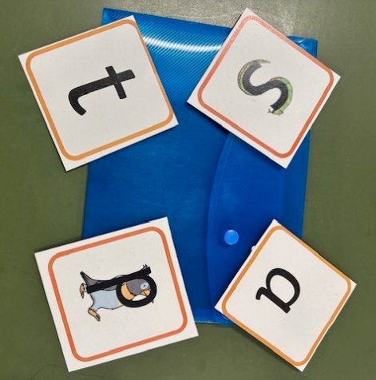
+
Little Wandle book
Sound pack
Your child needs to read their Little Wandle book and the contents of their sound pack to you 5 times each week. Please write what they have done with you in their yellow reading record.

