How are lives saved?
Authors  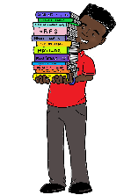  To become better authors we will start by looking at a range of texts including “Pig-Heart Boy” by Malorie Blackman and non-fiction texts about the circulatory system. There will be a focus on spellings and handwriting. All handwriting must be joined. | Mathematicians  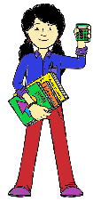  To develop as mathematicians, we will be moving onto work on fractions in particular and also beginning some work on measure. | Historians  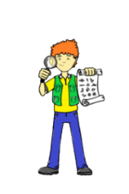  As Historians, we will be finding out about how historical discoveries led to improved understanding of how the systems of the human body work, | Athletes  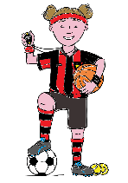  We will become better athletes by developing our fundamental movement skills of co-ordination, reaction and response. We will also be working on our skills in dance and swimming. | Geographers  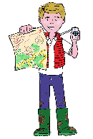  We will be revisiting our previous learning as a Geographer through map skills and revising vocabulary.
Artists  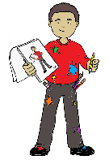  We will be looking at creating accurate diagrams of parts of the human body using the work of Da Vinci as an inspiration. | 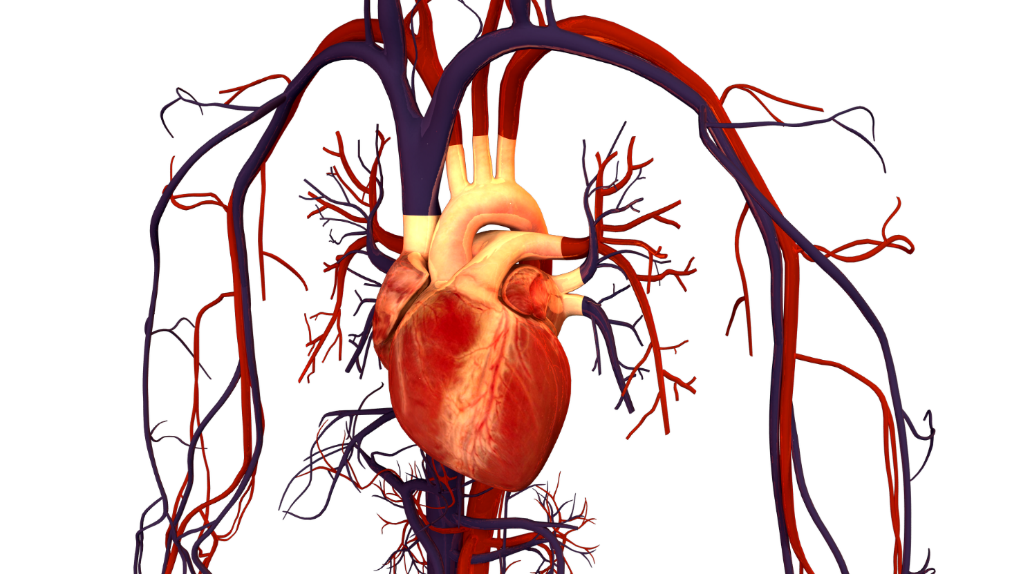 |  |  | Scientists (Key State)  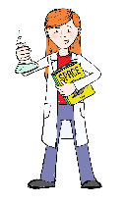  We will be learning about how the human circulatory system works. This will also involve learning some first aid skills.
Linguists  This term we will be using Language Angels to revise previous knowledge of the French language and begin to build on this with new vocabulary. |  |  |  |   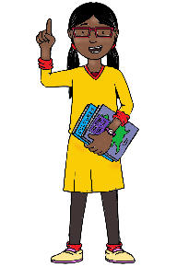  Philosophers  As Philosophers, we will be answering the question ‘What difference does it make to believe in Ahimsa (harmlessness), Grace (the generosity of God), and Ummah (community)?’

