Where does our food really come from?
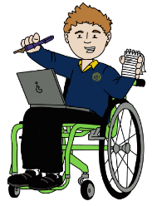  Authors  To become better authors we will be using the text ‘Scavengers’ by Darren Simpson. We will be working on cohesion in our writing and continuing a strong focus on spellings and handwriting. All handwriting must be joined. | Mathematicians  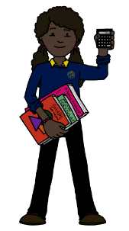  To develop as mathematicians, we will be moving onto ratio and algebra while continuing to revise our calculation methods for all four operations and our learning on fractions. | 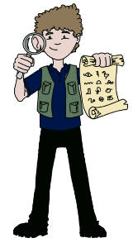  Historians  As Historians, we will revise our previous learning on William Harvey as well as considering how farming and food production techniques may have changed over time. | Athletes  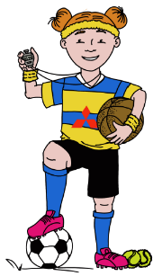  We will become better athletes by developing our fundamental movement skills of co-ordination, reaction and response. We will also be working on our skills in gymnastics and swimming. | Geographers (lead state)  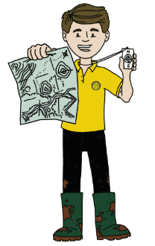  We will be exploring seasonality and how it links with climate zones. We will identify common foods which are imported to the UK and think about why the UK imports produce. We will also consider the meaning of fair trade and food miles.
Engineers  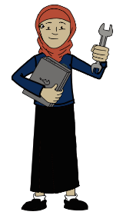  We will be developing our cooking and food preparation skills by creating some seasonal dishes linked to UK produce. | 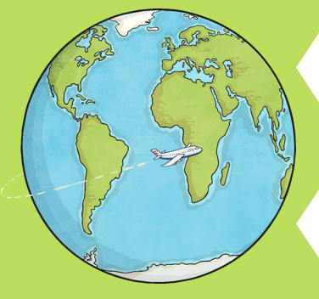  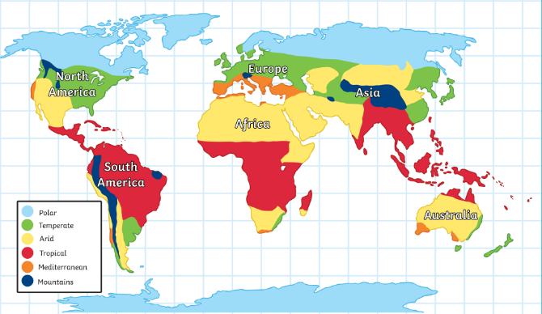  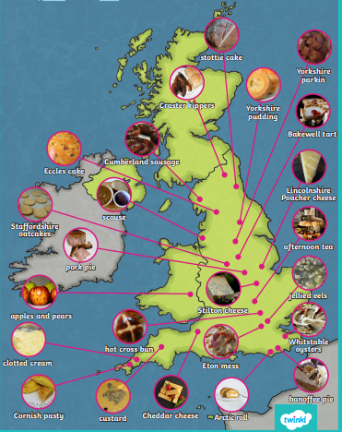 |  |  | Scientists  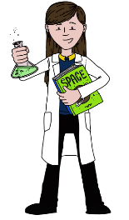  We will revise our knowledge of the digestive system and the circulatory system. We will revisit key vocabulary and scientific processes which occur within the human body.
Musicians  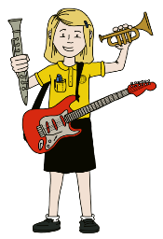  This term we will be considering emotions and musical styles and be answering the question, ‘How does music connect us with our past?’ We will also continue to take inspiration from our Green Area music cannon. |  |  |  | 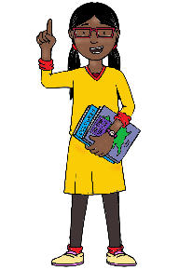  Philosophers  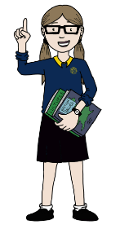  As Philosophers, we will be answering the question ‘What matters most to Christians and Humanists?’ We will continue to explore this idea in Term 4.

