Term 4 Spelling words: Year 2
These are words that we will be learning to read and spell during our daily spelling lessons. There are lots of fun ways you could practise reading and spelling these words at home:
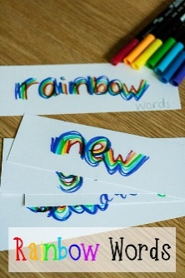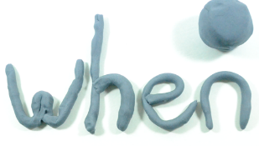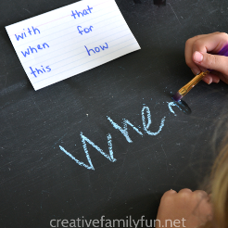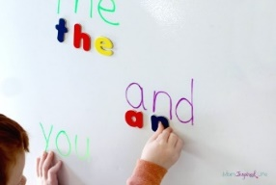
Week 1 | Week 2 | Week 3 | Week 4 | Week 5 | Week 6
danced  liked  scared  hoped  Homophones:  their  there  they’re | liking  scaring  being  seeing  where  wear | nicer  later  driver  dancer  see  sea | nicest  bravest  safest  bravest  right  write | shiny  noisy  scary  icy  to  too  two | edge  badge  giant  jam  one  won

