Term 4 Spelling words: Year 1
These are words that we will be learning to read and spell during our daily phonics lessons.
There are lots of fun ways you could practise reading and spelling these words at home:
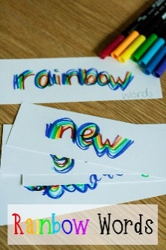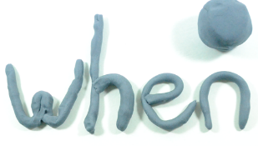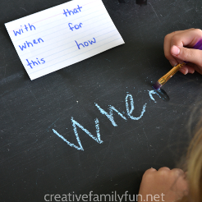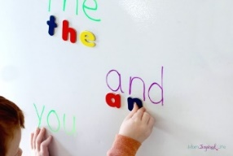
Week 1 | Week 2 | Week 3 | Week 4 | Week 5 | Week 6
word  pudding  square  dinosaur  Tricky words:  once  laugh | catch  picture  calm  father  Tricky words:  because  eye | small  different  squash  wear  Revise Tricky words:  thought  through | learn  write  whistle  muscle  Revise Tricky words:  many  any | chemist  school  chef  parachute  Revise Tricky words:  friend  your | celebrate  triumphant  adventure  musical  Revise Tricky words:  who  whole

