Red Area Homework Term 4 Enquiry: What did Brunel do for Great Britain?
WEEKLY HOME LEARNING
Here are some ways that you can support your child with their learning at home. Below are a range of activities including Reading, Spelling, Maths and tasks linked to our Enquiry. The suggested Spelling, Reading and Maths are tasks that can be completed weekly to practise key skills that children benefit from re-visiting regularly. Enquiry activities are suggested project tasks and you may wish to complete one per term with your child.
We welcome you to send projects and home learning into school when completed so that we can share and celebrate your child’s learning in school.
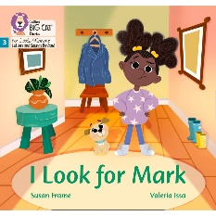  Reading  Each Friday, your child will bring home a Phonetically decodable book they’ve been reading in school so that you can continue to read it at home.  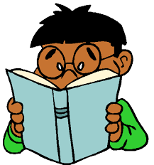  Your child will also choose and bring home a ‘Sharing book’ from our school library or class reading corner. This is a book that your child may not be able to read independently, but that you could read together at bedtime. | Spelling  Attached is a weekly grid of spellings that we’ve been practising reading and writing in our daily phonics lessons in school.  Please practise reading and spelling these words at home to help embed your child’s learning from this week. You may also wish to revisit spellings from previous week.  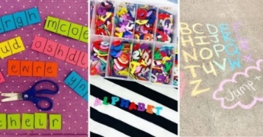  We do not ‘test’ your child reading and spelling these words. By practising at home, your child will develop confidence and fluency that will help them with their learning in school. |  | Maths  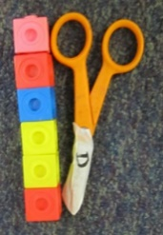  Online games to help consolidate key skills:  Measuring challenges:  This term we will be learning to use our maths skills to measure length and mass.  - Choose four toys. How tall is each toy? Can you order them from the smallest to tallest? Year 1s should measure using a non-standard units of measure such as blocks/paper clips. Year 2s should measure in cm/m using a ruler.  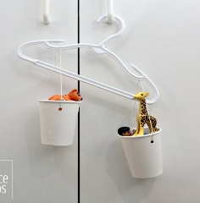  - Year 2: Use scales to measure the mass of ingredients. Can you help an adult at home prepare a meal and measure out the correct amount of ingredients using grams/kilograms?  Year 1: Make your own balancing scales using a coat hanger. Compare the mass of two items by attaching them to either end. Can you order a set of objects from the lightest to the heaviest?
  Year 1:  Place value Basket Ball (numbers to 50)  https://www.topmarks.co.uk/learning-to-count/place-value-basketball  Robot addition (numbers to 20)  https://www.topmarks.co.uk/addition/robot-addition | Year 2:  Hit the Button – Select times table facts for 2x, 5x, 10x table  https://www.topmarks.co.uk/maths-games/hit-the-button  Practise making amounts on the Toy Shop money game  https://www.topmarks.co.uk/money/toy-shop-money
PICK AND MIX HOMEWORK - YOUR CHOICE!
You may wish to choose a project task linked to this term’s enquiry. When you have completed your topic project, please bring it in to share with your class.
Being an engineer |  | Being an artist |  | Being an author | Being a historian
Use construction toys or junk modelling materials to make a model of SS Great Britain or Clifton Suspension bridge.  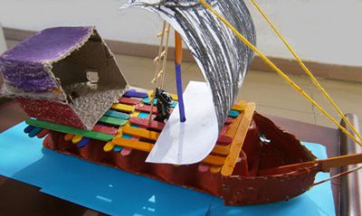 |  | You could go for a walk and sketch a bridge that you find in your local area.  Or find a picture of a famous bridge from around the world to sketch.  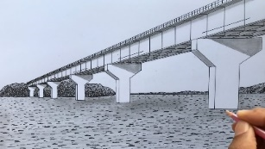 |  | Pretend you are one of the first passengers on The Great Western Railway.  Can you write a postcard or diary entry about your journey?  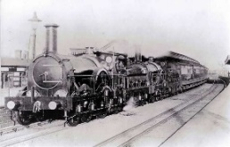  You may want to do some research to help you find out what it would’ve been like. | We are learning about timelines.  Can you create a timeline of your life from when you were born to today? Include important events like your first day at school and when you learnt to walk.  

