Linnaeus and Darwin- How are they connected?
  Authors  To become better authors we will be working on cohesion in our writing and continuing a strong focus on spellings and handwriting. All handwriting must be joined. | Mathematicians  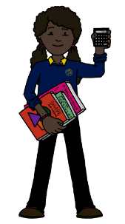  To develop as mathematicians, we will be moving onto decimals, statistics and shape whilst continuing to revise our calculation methods for all four operations and our learning on fractions. | 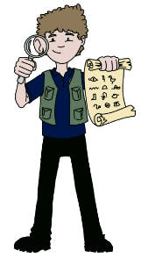  Historians  As Historians, we will discover how Karl Linnaeus and Charles Darwin made significant contributions to the development of natural history. | Athletes  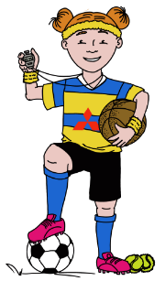  We will become better athletes by developing our fundamental movement skills of co-ordination, reaction and response. We will also be working on our skills in handball and jumpball. | Geographers  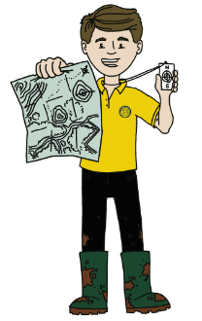  We will be revising seasonality and how it links with climate zones. We will remember common foods which are imported to the UK and think about why the UK imports produce. We will also consider the meaning of fair trade and food miles.
Artists  We will be developing sketching skills and watercolour skills. We will use the botanical drawings of Marianne North, Elizabeth Blackwell and Wilfred Blunt. | 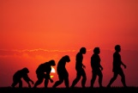 |  |  | Scientists (Lead State)  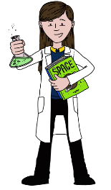  We will be learning about the Theory of Evolution, adaptation, inheritance and variation. We will also find out about how scientists classify different plants and animals.
Linguists  We will be continuing our work in learning French vocabulary. This term will look at pets. |  |  |  | 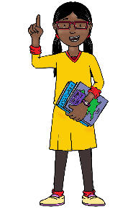  Philosophers    As Philosophers, we will be continuing our work on answering the question ‘What matters most to Christians and Humanists?’

