Why are shadows important?
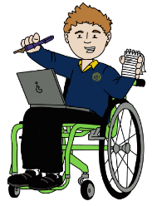  Authors  To become better authors we will be working on cohesion in our writing and continuing a strong focus on spellings and handwriting. All handwriting must be joined. | Mathematicians  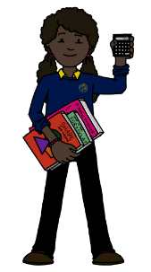  To develop as mathematicians, we will be continuing work on statistics and shape and position whilst continuing to revise our calculation methods for all four operations and our learning on fractions. | 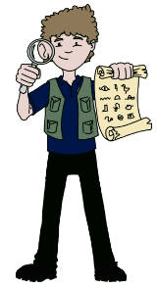  Historians  As Historians, we will revise our work on Karl Linnaeus and Charles Darwin and consider the impact of legacy. | Athletes  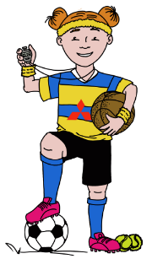  We will become better athletes by developing our fundamental movement skills of co-ordination, reaction and response. We will also be working on our skills in athletics, disc-golf and foot-golf | Geographers  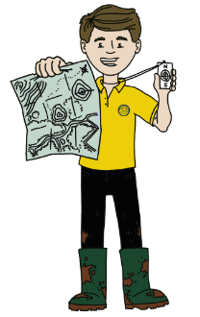  We will be revising countries and continents, knowing where our country is in the world and devising methods to remember the position of other places.
Artists  We will be developing sketching skills in the chiaroscuro style. We will look at the work of artists including Da Vinci and Caravaggio to see how this style was used. We will also develop skills in turning 2D art into 3D sculptures. 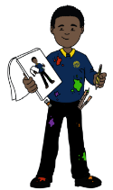 | 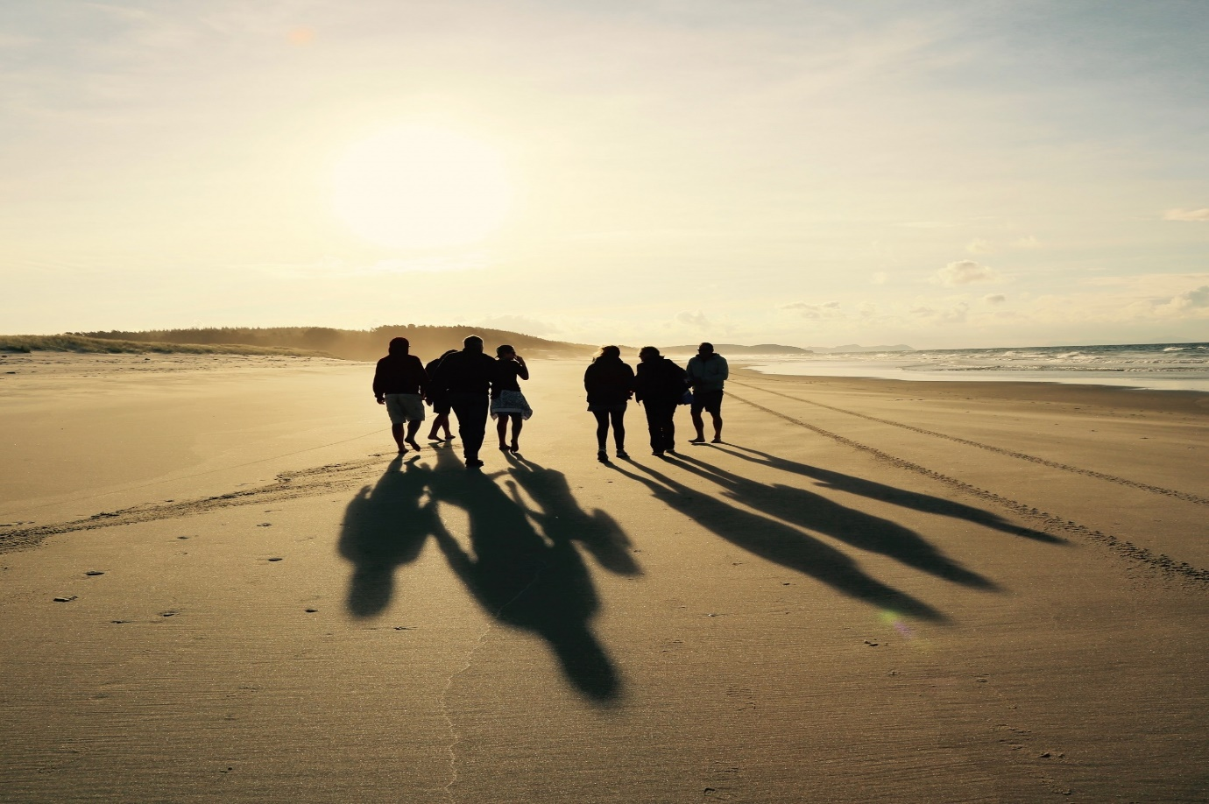 |  |  | Scientists (Lead State)  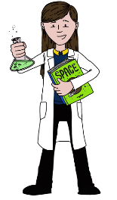  We will be learning about how we see and how we perceive colours. We will look at how shadows are formed and how they can appear to change shape and size.
Musicians  This term we will be continuing to use Charanga to teach our Music lessons. This term children will be developing their understanding of the question “What does music tell us about our community?”  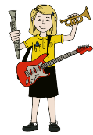 |  |  |  | 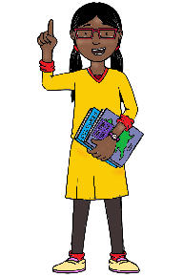  Philosophers  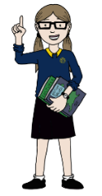  As Philosophers, we will be answering the question ‘What do religions say to us when life get’s hard?’

