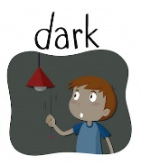
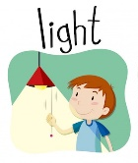
Blue Area Homework – Term 1
Enquiry: Where does the darkness come from?
WEEKLY HOME LEARNING
Being a Reader | Being an Author | Being a Mathematician
Reading Homework  - Please read 5 times each week.  - You should read your school reading book aloud to an adult at home. This will help to improve your fluency and prosody. Your adult can then ask you some questions about what you have been reading so that you can practise your comprehension skills.  Make sure that you remember to take home a school reading book every day and you should change it when you have finished reading it. | Spelling Homework  - The spelling lists for this term can also be found on the back of this homework sheet.  - These words are the words that you will be learning in your spelling lessons.  - Please practise reading and spelling these words at home until you can spell them from memory.  - Your teacher will check that you know how to spell these words, the following Monday.  - You should practise spelling these words using your login for the spelling shed website, which has been sent home. Assignments will be set each week to help you learn your spellings and there are lots of fun games that you can play which will help you.  https://www.spellingshed.com/en-gb/ | Year 4 Key Multiplication Facts  Each day in school, we will take part in a ‘Multiplication Challenge’ to enable us to learn to understand and be able to recall multiplication and division facts from memory. By the end of Year 4, you will need to be able to fluently recall multiplication and division facts for all of the times tables up to and including 12 x 12. You will learn the tables one at a time until you are ready to move on to the next one.  Times Table Homework  You should practise rapid recall of the times tables that you are learning in school by spending a few minutes each day on your tables. (Multiplication and Division facts)  You can do this using the Times Tables Rock Stars app or website using your personal login (Inside your school planner) or in any way that you choose.  Remember, when you are chanting the facts you need to say the fact as we do in school. To say a multiplication fact, always look for the biggest factor in the calculation to say first and stick to the ‘sound pattern’.  EG for 4 x 6 = 24, we will say 6 4s are 24.  For a division fact, we say it as the multiplication.  Year 3 Factual Fluency  Each day in school, we will be practicing our factual fluency in number. This means we will be going over lots of skills we learnt in year 2. To help you can practice with the following activities:  - Number bonds to 10  - Doubling numbers up to 5  - Finding 1 more or less than a number
PICK AND MIX ENQUIRY HOMEWORK – YOUR CHOICE!
Choose from the following projects. At least one to be completed before the end of term. When you have completed your project, please bring it in to share with your class.
Being a Scientist    How many light sources can you find? Go on a quest to find as many different light sources as you can. How many natural or artificial (man-made) light sources can you discover? Make a poster, presentation or list to share what you have found. | Being an Author  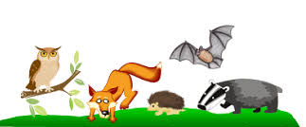  Which animals are nocturnal? You could choose one animal to research or you could find out about what special features nocturnal animals have adapted to help them in the darkness. Create a fact-file, report or information poster to present to your class | Being an Geographer  Where is your shadow? Choose a sunny day to investigate your shadow or the shadows made by the objects in your garden. You could have a go at drawing around the shadows on the ground with water and an old paintbrush or some chalk or on paper. What do you notice about the position of your shadow throughout the day? Think about the direction of the sun and where your shadow falls at different times of the day. You can present what you have found out to your class in any way that you like.    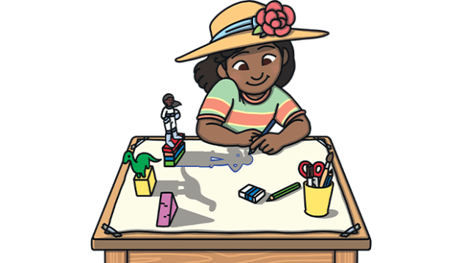 | Being an Artist/Engineer  Can you design a sun hat or a pair of snazzy sunglasses that would help to protect your eyes from the bright sun?    

Term 1 Spelling Word Lists.
Below are the spelling lists for this term. Please make sure you are learning to spell these words each week through regular spelling practise. This can be through a mixture of completing the assignments set for you on the Spelling Shed website https://www.spellingshed.com/en-gb/ and by practising them in other ways that suit you.
Year 3 Spelling Shed Lists
WB 7.9.26 | WB 14.9.26 | WB 21.9.26 | WB 28.9.26 | WB 5.10.26 | WB 12.10.26 | WB 19.10.26
List 1  Words where the digraph ‘ou’ makes an /ow/ sound | List 2  Words where the digraph ‘ou’ makes an /u/ sound | List 3  Words where ‘y’ makes an /i/ sound | List 4  Words ending in ‘-sure’ | List 5  Words ending in ‘-ture’ | List 6  Challenge words | List 7  Words with the prefix ‘re’
'mouth  around  sprout  sound  spout  trout  ouch  found  hound  proud | touch  cousin  double  enough  country  encourage  trouble  flourish  young  couple | gym  symbol  myth  synonym  Egypt  lyrics  pyramid  system  mystery  gymnastics | measure  treasure  pleasure  enclosure  pressure  composure  leisure  exposure  closure  disclosure | picture  adventure  creature  furniture  nature  capture  future  sculpture  fracture  mixture | actual  bicycle  answers  circle  earth  enough  fruit  island  often  popular | redo  refresh  return  reappear  redecorate  revenge  review  replay  reaction  rebound

Year 4 Spelling Shed Lists
WB 7.9.26 | WB 14.9.26 | WB 21.9.26 | WB 28.9.26 | WB 5.10.26 | WB 12.10.26 | WB 19.10.26
List 1  Words that are homophones or near homophones | List 2  Words with the prefix ‘in-’ meaning ‘not’ | List 3  Words with the prefixes ‘il-’, ‘im-’ and ‘ir-’ | List 4  Words with the prefix ‘sub-’ meaning ‘below’ or ‘further divided’ | List 5  Words with the prefix ‘inter-’ meaning ‘between’ or ‘among’ | List 6  Challenge words | List 7  Words with the suffix ‘ate’ or ‘tion’
accept  except  knot  not  peace  piece  plain  plane  weather  whether | inactive  indefinite  incorrect  inelegant  invisible  incurable  insecure  inability  inflexible  inadequate | illegal  impatient  illegible  imperfect  immature  irregular  immortal  irrelevant  impossible  irresponsible | submarine  submerge  subheading  subtropical  subtitle  submit  subway  subdivide  subject  substandard | interact  intercity  international  interfere  interview  intercept  intercom  internet  interchange  interface | strength  opposite  women  believe  interest  calendar  grammar  straight  appear  increase | information  vibration  decoration  donation  population  coronation  detonation  location  generation  illustration

