Boys 50m Sprint

0:07:50 (2019)
Girls 50m Sprint
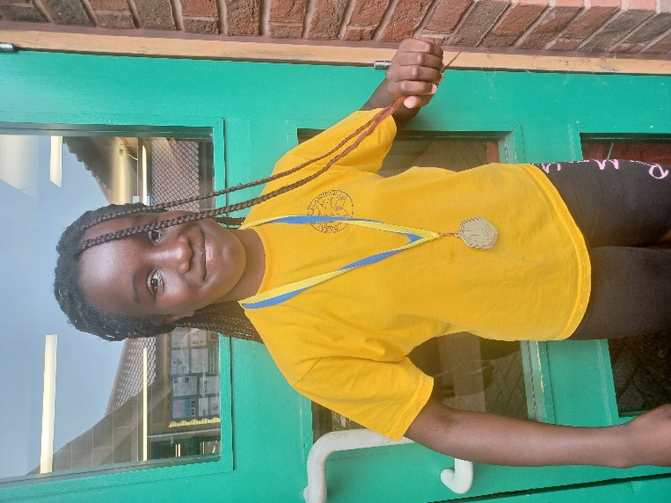
0:07:32 (2023)
Boys’ Cross Country

3:04:43 (2016)
Girls’ Cross Country
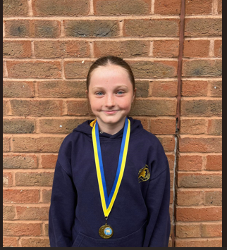
3:20:78 (2025)

Boys Throw
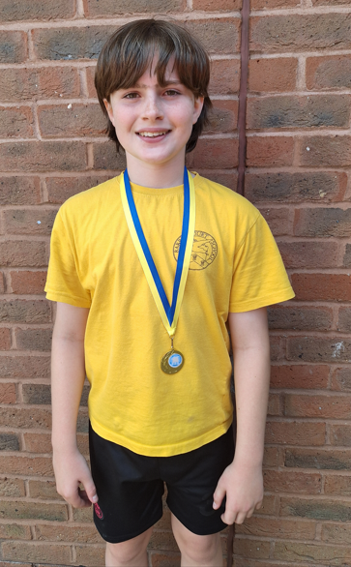
36.44m (2024)

Girls’ Throw
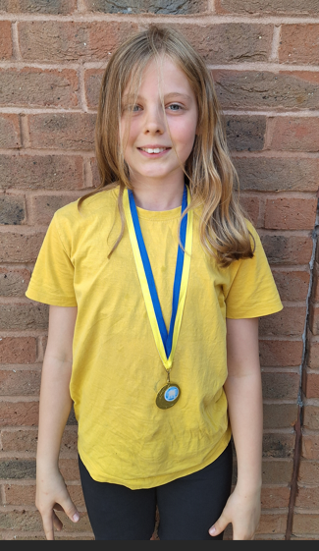
20.28 Metres (2024)

Boys Jump

2.08m (2019)

Girls Jump
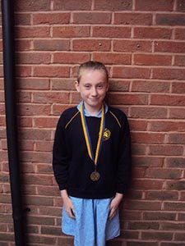
2.03m (2018)

