

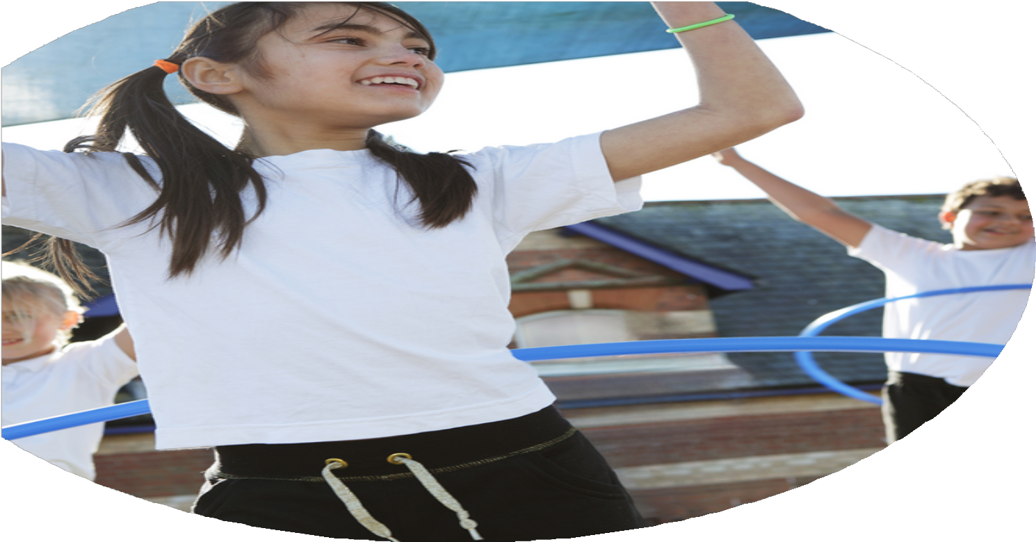
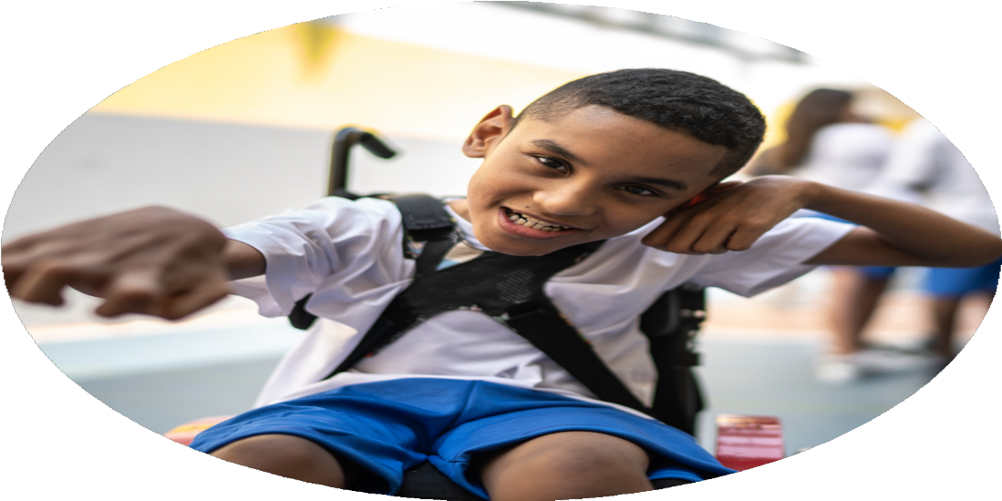




PE Funding

Evaluation Form

Commissioned by

Created by

Images courtesy of Youth Sport Trust

PE Funding Evaluation Form

It is intended that this template should be used as preparation for the completion of the statutory digital reporting tool being introduced this academic year. You can upload data (including swimming) from this template onto this platform once it becomes accessible.
Before you decide how you are going to use the funding for this academic year you should reflect and evaluate the impact of your use of the funding in 2023/24.
All spending of the funding must conform with the terms outlined in the Conditions of Grant document. The template is a working document that you can amend/update during the year.
Based on your evaluation of last year’s funding you should decide what you intend to do this academic year, how you will do it, and what impact you expect it to have.

It is important that the funding is used effectively and based on your school’s needs.
You must use the funding to make additional and sustainable improvements to the PE and sport in your school. You must develop and add to the PESSPA activities that your school already offers.

Summative digital reporting from June 2025 will continue to include swimming and water safety information therefore funding can be used to provide top-up lessons where necessary to ensure pupils meet national curriculum swimming requirements.

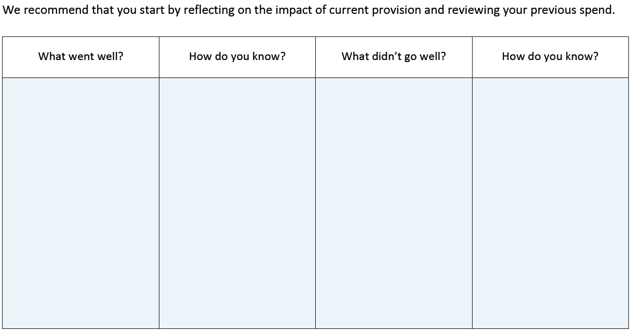
Staff audits
Turnover of staff meant that confidence in PE teaching wasn’t as high as previous years.
Nearly 60% of school population had taken part in at least one inter-school sport fixture.

156 inter-school sports fixtures completed over 36 different sports.

Girls’ football team reached the national finals of two competitions with finals taking place at Derby’s Pride Park and Brentford’s G-Tech Stadium.
Participation in inter-school sports had increased.

Achievements in higher-level sports
What are your plans for 2024/25?

Intent
How are you going to action and achieve these plans?

Implementation
Use of sports coaches for CPD.

Signpost CPD opportunities for staff with local PE network.

Use of staff meetings to lead training

Virtual competitions- skipping and speed bounce

Other competitions- football and swimming at least.

Sports coaches to lead intervention groups in teamwork and sporting behavior with reluctant participators.

Identify children in participation database and monitor opportunities across the year.
Increase confidence in PE teaching for all teachers.

Begin PE network for new multi-academy trust schools in Mosaic

Target reluctant participators in sport

What impact/intended impact/sustainability are you
expecting?
How will you know? What evidence do you have or
expect to have?
Reluctant participators to take part in at least one inter-school fixture and to attend a school club.

Participation database (internal and external with sports partnership).

Assessment database from PE lessons.

All children to have increased participation either in intra-school or inter-school activities and competitions..

All children to have increased confidence in taking part in PE and Sport.

Teachers have increased confidence in teaching and assessing PE lessons

What impact/sustainability have you seen?
What evidence do you have?
Reluctant participators to take part in at least one inter-school fixture and to attend a school club.

Participation database (internal and external with sports partnership).

Assessment database from PE lessons.

The school continues to be one of the highest, if not the highest, participator in inter-school sports in our area (see external sports partnership data).
We have completed 145 inter-school sports fixtures across 34 different sports in the academic year 2024-25.
155 children out of 296 in the school community have taken part in at least one inter-school sport fixture during the academic year.

We have led the creation of four new competitions for our MAT.

Swimming data-
82% of Year 6 children can swim competently, confidently and proficiently over a distance of 25 metres.
77% of Year 6 children can use a range of strokes.
36% of Year 6 children can perform safe self-rescue in the water.

Assessment data has been more robustly recorded this academic year.

Children have been more confident in more unusual sports this year as they become used to them.

Increase in number of young leaders supporting sports activities.

Increase in range of intra-school sports.

