How do we all live together?
Authors  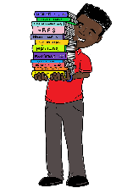  To become better authors we will start by looking at a range of texts which will allow us to create non-fiction, fiction and narrative texts. There will be a focus on spellings and handwriting. All handwriting must be joined. | Mathematicians  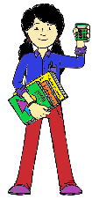  To develop as mathematicians, we will be revisiting our knowledge of place value and then developing our skills in addition and subtraction. | Historians (Key state)  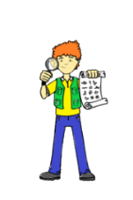  As Historians, we will investigate the lives of the Ancient Greeks. We will be comparing daily life in Ancient Greece compared to modern daily life. We will also be diving into democracy. | Athletes  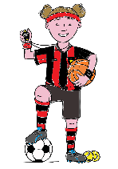  We will become better athletes by developing our fundamental movement skills of co-ordination, reaction and response. We will also be working on our skills in netball and swimming. | Geographers  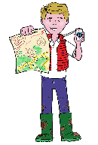  We will be revisiting our previous learning as a Geographer through map skills and revising vocabulary.
Artists  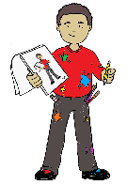  We will be looking at creating accurate self-portraits using mirrors and incorporating the skill of sketching and shading. | 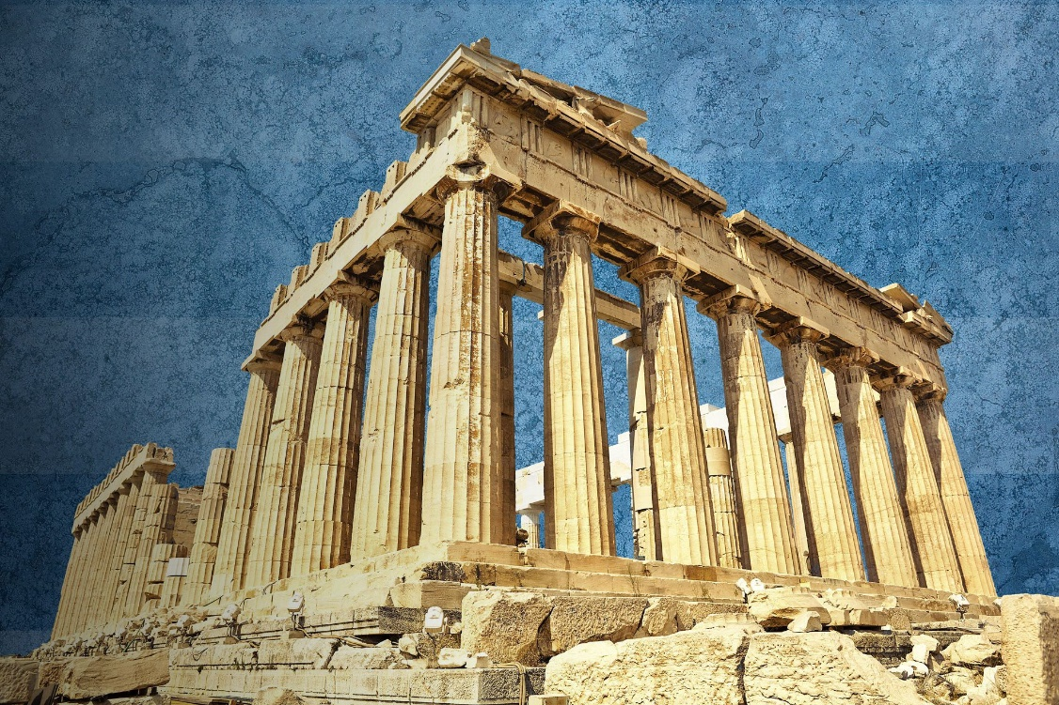 |  |  | Scientists  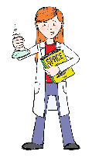  We will be revisiting our previous learning as a Scientist through revising vocabulary during early morning tasks.
Musicians  This term we will be continuing to use Charanga to teach our Music lessons. This term children will be developing melodic phrases and thinking about the question ‘How does Music bring us together?’ |  |  |  | 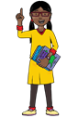  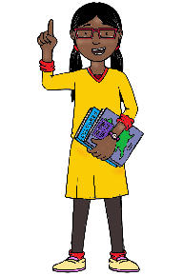  Philosophers  As Philosophers, we will be answering the question ‘How and why should religious communities do more to care for the Earth?’

